1.Factorial (oops).
public class factorial {
void fact(int n){
int fact=1;
for(int i=1;i<=n;i++){
fact=fact*i;
}
System.out.println(fact);
}
public static void main(String[] args) {
factorial f=new factorial();
f.fact(5);
}
}

Output.
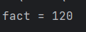

2.Area of circle (oops).
a)with passing parameters to constructor.
public class circle {
int r;
circle(int a){
r=a;
}
void cir(){
double area=3.14*r*r;
System.out.println("area of circle = "+area);
}
public static void main(String[] args) {
circle c=new circle(3);
c.cir();
}
}

output.
b)without passing parameters in constructor.
public class over {
int r;
over(){
}
void cir(int r){
double area=3.14*r*r;
System.out.println("area of circle = "+area);
}
public static void main(String[] args) {
over c=new over();
c.cir(3);
}
}

output.

3.Simple interest (oops).
import java.util.*;
public class roi {
int p,y,r;
roi(int a,int b,int c){
p=a;
y=b;
r=c;
}
void interset(){
int roi=p*y*r/100;
System.out.println("interest = "+roi);
}
public static void main(String[] args) {
int p,y,r;
Scanner s=new Scanner(System.in);
System.out.println("enter principle amount ");
p=s.nextInt();
System.out.println("enter no of years ");
y=s.nextInt();
System.out.println("enter rate of interest ");
r=s.nextInt();
roi r1=new roi(p,y,r);
r1.interset();
}
}

output.
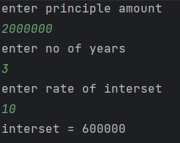

4.Polymorphism.
public class polymorphism {
void test(){
System.out.println("no parameters");
}
void tes(int a){
System.out.println("single parameter");
System.out.println("a = "+a);
}
void test(int a,int b){
System.out.println("double parameter");
System.out.println("a = "+a+" b = "+b);
}
void test(int a,char b,float c){
System.out.println("different datatypes of parameter");
System.out.println("int a = "+a+" char b = "+b+"float c = "+c);
}
int test(int a){
return a*a;
}
public static void main(String[] args) {
polymorphism p=new polymorphism();
p.test();
p.tes(10);
p.test(20,30);
p.test(40,'s',6.9f);
int res=p.test(5);
System.out.println("return type parameter ");
System.out.println("res="+res);
}
}

output.
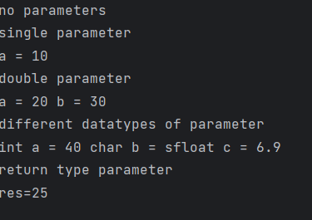

5.Overloading.
public class polyover {
void test(){
System.out.println("no parameters");
System.out.println("welcome to java");
}
void tes(String a){
System.out.println("single parameter only string");
System.out.println(a);
}
void test(String a,int b){
System.out.println("double parameter string and integer");
for(int i=0;i<b;i++) {
System.out.println(a);
}
}
public static void main(String[] args) {
polyover p=new polyover();
p.test();
p.tes("welcome to polymorphism");
p.test("welcome to method overloading",3);
}
}

output.
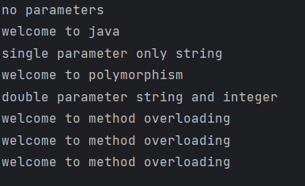
6.Inheritance.
public class inheritance {
protected double area;
void circle(int r){
area=3.14*r*r;
}
}
class cylinder extends inheritance{
private double vol;
void cal1(int h){
vol=area*h;
}
void diplay(){
System.out.println("area of circle = "+area);
System.out.println("volume of cylinder = "+vol);
}
public static void main(String[] args) {
cylinder c=new cylinder();
c.circle(5);
c.cal1(10);
c.diplay();
}
}

output.
